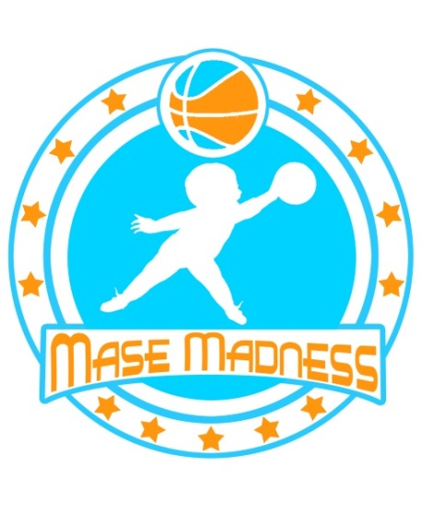
MASE MADNESS
6th Annual Basketball Tournament 2017 Tournament Registration Form $300 Per Team
*Each Team may have up 10 Players on their Team Roster
Send Registrations and Fees to:
MASE MADNESS
74 Bennett Avenue
Binghamton, NY 13905
Email:
info@masemadness.com
Please make checks payable to:
The Mason P. McKan Benevolence Fund, Inc.

Team Name (*To be determined by the committee):_________________
*Team Sponsor will be appointed by MM Committee unless your team has “Full Sponsorship”. Full Team Sponsorship is $575. Full Sponsor will select their teams AND fund the players’ Entrance Fee. That sponsors name will appear on their jerseys.
Division:__________________________
Team Contact:________________________
Phone:___________________________
Email Address:____________________________
Mailing Address:____________________________________
City:__________________ State:________ Zip Code:________
Player Name- Jersey Size and Number: Ex.: Mason McKan- XXL #13
- ______________________ 6) _____________________
- ______________________ 7) _____________________
- ______________________ 8) _____________________
- ______________________ 9) _____________________
- ______________________ 10) _____________________
**All Girls and Boys High School Teams MUST have an Adult Representative (Team Captain) on their bench.
Team Captain: ___________________________ Date:________________________
Please print this form, complete all fields, and return it with payment NO LATER THAN JULY 18^{th,} 2017*
Once Registration Forms are Submitted There is NO Adding Players to Your Roster. Tournament Dates 8/11-13
*Your Team Is Officially Registered once this form and payment is received. Face Book and Web Site will be updated as teams are formed.

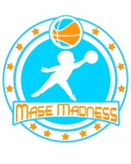
MASE MADNESS
OFFICIAL RULES
*Rules subject to change prior to Tournament*
ALL GAMES will start at their scheduled times and THERE IS NO GRACE PERIOD!
ALL TEAMS ARE GUARENTEED AT LEAST 3 GAMES
GAME STRUCTURE
- 20 minute halves running clock.....clock stops LAST TWO MINUTES of each GAME.
- Halftime will be 2 minutes. Amount of time for pregame warm ups depends on the game before you (Games will start ON TIME). On average teams will probably be given between 2-3 minutes to warm up, so arrive early to get loose and STRETCH.
- 2 point shooting fouls will yield 2 foul shots....3 point shooting fouls will yield 3 foul shots.
- Each technical foul will result in 2 free throws and the ball. 2 technicals will result in ejection from the game (techs count as personals too). 3 technicals over the course of the tournament and the player will be removed from the tournament.
- Each player is allowed 5 personal fouls. 7 team fouls will result in a one and one and 10 team fouls will result in 2 foul shots
- 1st Overtime is a 2 minute overtime....2nd overtime is sudden death. IF fouled on a shooting foul in overtime the player must make the free throw to end the game. IF fouled on the floor, the player must make the front end of the one-and-one to end the game. All overtime fouls will be one-and-one.
PLAYOFF SEEDING
Top 2 teams in each division will make the playoff round. Tie breakers to determine playoffs:
1. Head to Head
2. Point Differential (a forfeit will count as a 10 point win)
3. Points allowed
- If we have 3 teams within a division that are 2-1 and one team 0-3, this means it will come down to point differential since you will all have beaten each other.....So play hard the entire game!!
- In determining playoff seeding, it will come down to:
1. record
2. head to head
3. point differential
4. points allowed
5. coin flip
If we have (for example) three teams that are 3-0, they will be seeded 1 to 3 based on their point differential first, and points allowed second. If they are still tied we will go to a coin flip.
UNIFORM POLICY
- Everyone must wear the team jersey provided, for the duration of the tournament. Team players will be assigned a Team Sponsor to be selected by the Mase Madness Committee members. These jerseys will be handed out at check-in on the 1st day of the tournament so please plan to arrive early enough to provide time for jersey distribution.

